J2ME Sample Game 8 – Hard Drive

- Screenshots

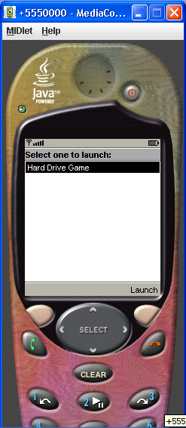
Figure 1 – Start Up Screen
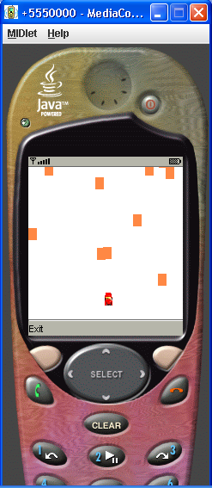
Figure 2 – Hard Drive Game

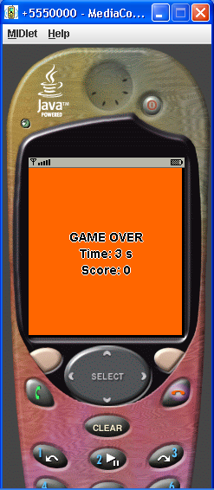
Figure 3 – Game Over Screen
- Source Codes

- HardDriveMIDlet.java

/* HardDriveMIDlet.java : Container MIDlet */

import java.io.IOException;
import javax.microedition.midlet.MIDlet;
import javax.microedition.lcdui.*;

public class HardDriveMIDlet extends MIDlet implements CommandListener
{
private Display dgDisplay;
private HardDriveCanvas hdCanvas;
private GameOverCanvas goCanvas;

static final Command ExitCommand = new Command("Exit", Command.EXIT, 0);

public HardDriveMIDlet( )
{
// Create the main Display
dgDisplay = Display.getDisplay(this);
}

protected void startApp() //throws MIDletStateChangeException
{
try
{
hdCanvas = new HardDriveCanvas(this, "/car.png", "/obstacle.png");
hdCanvas.start();
hdCanvas.addCommand(ExitCommand);
hdCanvas.setCommandListener(this);
}
catch (IOException ioe)
{
System.err.println("Problem loading image "+ioe);
}
//Set newly created canvas as current canvas
dgDisplay.setCurrent(hdCanvas);
}

public void pauseApp()
{
}

public void destroyApp(boolean unconditional)
{
hdCanvas.stop();
}

public void commandAction(Command c, Displayable s)
{
if (c.getCommandType() == Command.EXIT)
{
destroyApp(true);
notifyDestroyed();
}
}

public void HardDriveCanvasGameOver(long time, int score)
{
hdCanvas.stop();
try
{
goCanvas = new GameOverCanvas(this, time, score);
goCanvas.start();
//Command quitCommand = new Command("Quit", Command.EXIT, 1);
goCanvas.addCommand(ExitCommand);
goCanvas.setCommandListener(this);
}
catch (Exception exp)
{
System.err.println("Problem loading image "+exp);
}
dgDisplay.setCurrent(goCanvas);
}
}

- HardDriveCanvas

import java.io.IOException;
import javax.microedition.midlet.MIDlet;
import javax.microedition.lcdui.*;
import javax.microedition.lcdui.game.*;

class HardDriveCanvas extends GameCanvas implements Runnable
{
private HardDriveMIDlet midlet;
private Sprite carSprite;

private LayerManager layerManager;
private ObstacleManager obsManager;

private boolean gameRunning, collision = false;

private int width;
private int height;

private long gameDuration;

public HardDriveCanvas(HardDriveMIDlet hdmidlet, String carImageName, String obsImageName) throws IOException
{
super(true);

this.midlet = hdmidlet; //used later

layerManager = new LayerManager();

width = getWidth();
height = getHeight();

layerManager.setViewWindow(1,1,width - 2, height -2);

createCar(carImageName);

obsManager = new ObstacleManager( this, layerManager, obsImageName);

}

private void createCar(String carImageName) throws IOException
{
Image carImage = Image.createImage(carImageName);
carSprite = new Sprite(carImage);

// Put the sprite close to bottom center
carSprite.setPosition(width/2,height - 30);

layerManager.append(carSprite);
}

public void start()
{
gameRunning = true;
Thread gameThread = new Thread(this);
gameThread.start();
}

public void stop()
{
gameRunning = false;
}

public void run()
{
Graphics g = getGraphics();
int timeStep = 300;
obsManager.renderObstacles();
long startTime = System.currentTimeMillis();
while (gameRunning) //is true
{
tick();
input();
render(g);

long endTime = System.currentTimeMillis();
long duration = (int)(endTime - startTime);
gameDuration = duration / 1000; //game time in seconds

try
{
Thread.sleep(timeStep );//- duration);
obsManager.MoveObstacles();
}
catch (InterruptedException ie)
{
stop();
}
}
}

private void tick()
{
if(!collision)
checkCollision();
if (collision)
{
//Game over
int score = obsManager.getScore();
midlet.HardDriveCanvasGameOver(gameDuration,score);
//stop();
}
}

private void input()
{
int keyStates = getKeyStates();
int currentY = carSprite.getY();
int currentX = carSprite.getX( );
if ((keyStates & LEFT_PRESSED) != 0)
carSprite.setPosition(Math.max(0, currentX-5), currentY);
if ((keyStates & RIGHT_PRESSED) != 0)
carSprite.setPosition(Math.min(170, currentX + 5), currentY);
}

private void render(Graphics g)
{
g.setColor(0, 0, 0); // black
g.fillRect(0, 0,getWidth()-3, getHeight()-3);

layerManager.paint(g,0,0);

flushGraphics();
}

private void checkCollision()
{
if (obsManager.hitTest(carSprite))
collision = true;
}
}

- ObstacleManager.java

/*ObstacleManager.java : creates and manages obstacles */

import java.io.IOException;
import javax.microedition.lcdui.*;
import javax.microedition.lcdui.game.*;
public class ObstacleManager
{
private Sprite [] obstacles;
//private boolean [] active;
//private int [] xpos;
//private int [] ypos;

private LayerManager layerManager;
private GameCanvas hdCanvas;

private static final int MAX_OBS = 10; //maximum number of obstacles appearing at a time in car's path, could be changed to any desired number

private static int Score = 0;

/** Creates a new instance of ObstacleManager */

public ObstacleManager(GameCanvas canvas, LayerManager lm, String obsFileName) throws IOException
{
hdCanvas = canvas;
layerManager = lm;
createObstacles(obsFileName);
}

private void createObstacles(String obsImageName) throws IOException
{
Image obsImage = Image.createImage(obsImageName);
obstacles = new Sprite[MAX_OBS];

//active = new boolean[MAX_OBS];

//xpos = new int[MAX_OBS];
//ypos = new int[MAX_OBS];

for (int i=0; i < MAX_OBS; i++)
{
obstacles[i] = new Sprite(obsImage);
obstacles[i].setVisible(false);

layerManager.append(obstacles[i]);
}
}

//private int lastRendered = 0;
public void renderObstacles()
{
for (int i=0; i < MAX_OBS; i++)
{
//obstacles[i].setPosition(locations[i], 0);
ReSetObstaclesPosition();
obstacles[i].setVisible(true);
}
}

public void MoveObstacles()
{
for (int i=0; i < obstacles.length; i++)
{
int currentX = obstacles[i].getX( );
int newY = obstacles[i].getY( ) + 14; // 14 is image height

if (newY >= 177)
{
//obstacles[i].setVisible(false);
Score+=1;
java.util.Random random = new java.util.Random();
int yPos = (random.nextInt()>>>1) % 170;
int xPos = (random.nextInt()>>>1) % 170;

//obstacles[i].setPosition(currentX , - yPos);
obstacles[i].setPosition(xPos , - yPos);
}
else
{
obstacles[i].setPosition(currentX, newY);
}
}
}

public void ReSetObstaclesPosition()
{
java.util.Random random = new java.util.Random();
for( int i = 0; i < 10 ; i++)
{
int nyPos = (random.nextInt()>>>1) % 170;
int nxPos = (random.nextInt()>>>1) % 170;
obstacles[i].setPosition(nxPos, -nyPos );
}
}

public boolean hitTest(Sprite carSprite)
{
boolean retval = false;
for (int i=0; i < obstacles.length; i++)
{
if (carSprite.collidesWith(obstacles[i], true))
{
retval = true;
break;
}
}
return retval;
}
public int getScore()
{
return Score;
}
}

- GameOverCanvas.java

import javax.microedition.lcdui.*;
import javax.microedition.midlet.MIDlet;

class GameOverCanvas extends Canvas
{
private HardDriveMIDlet midlet;
private long time;
private int score;

GameOverCanvas(HardDriveMIDlet hdmidlet, long gtime, int gscore)
{
super();
this.midlet = hdmidlet;
this.time = gtime;
this.score = gscore;
setFullScreenMode(true);
}

public void start()
{
}

public void paint(Graphics g)
{
int width = getWidth();
int height = getHeight();

// clear screen to black
g.setColor(0,0,0);
g.fillRect(0, 0, width, height);
// clear screen to orange
g.setColor(255,100,0);
g.fillRect(0, 0, width - 3, height - 3);

// Write message. We use a trick to make outlined text: we draw it
// offset one pixel to the top, bottom, left & right in white, then
// centred in black.
g.setFont(Font.getFont(Font.FACE_PROPORTIONAL, Font.STYLE_BOLD, Font.SIZE_LARGE));

int centerX = width / 2;
int centerY = height / 2;
g.setColor(0x00FFFFFF); // white
drawText(g, centerX, centerY - 1);
drawText(g, centerX, centerY + 1);
drawText(g, centerX - 1, centerY);
drawText(g, centerX + 1, centerY);
g.setColor(0x00000000); // black
drawText(g, centerX, centerY);
}

private void drawText(Graphics g, int centerX, int centerY)
{
int fontHeight = g.getFont().getHeight();
int textHeight = 3 * fontHeight;
int topY = centerY - textHeight / 2;

g.drawString("GAME OVER", centerX, topY, Graphics.HCENTER | Graphics.TOP);
g.drawString("Time: " + time + " s", centerX, topY + fontHeight, Graphics.HCENTER | Graphics.TOP);
g.drawString(("Score: " + score), centerX, topY + 2 * fontHeight, Graphics.HCENTER | Graphics.TOP);
}
}

